# Plans

* **~~Saving Loaded Data ( Writing it into a file )~~**
* **~~Loading Saved Data ( Reading it from a file )~~**
* **~~Log In~~**
  + **~~Check whether entered CNIC is in valid format~~**
  + **~~Find the CNIC in the list of customers and drivers~~**
  + **~~Check if the entered password matches the account password~~**
  + **~~Check if driver account is logging in or customer account is logging in~~**
  + **~~Log in the correct account~~**
* **~~Sign Up~~**
  + **~~Make sure all information is in valid format~~**
  + **~~Call Driver or Customer constructor depending on user’s choice~~**
* **~~Customer Login~~**
  + **~~Display Customer details (Name CNIC and balance)~~**
  + **~~Allow customer to see available drivers~~**
    - **~~Allow Customer to see service history of driver~~**
  + **~~Allow Customer to deposit money~~**
    - **~~Add balance~~**
  + **~~Allow Customer to see available vehicles~~**
    - **~~Allow Customer to see service history of vehicles~~**
  + **~~Allow customer to place an order~~**
  + **~~Allow Customer to see orders they have placed~~**
  + **~~Allow Customer to confirm order~~**
    - **~~Deduct balance and add to driver account~~**
  + **~~Allow Customer to cancel order~~**
    - **~~Return order cost after deducting 5%~~**
  + **~~Allow Customer to delete account~~**
* **~~Driver Login~~**
  + **~~Display Driver details (Name CNIC and balance)~~**
  + **~~Allow Driver to withdraw money~~**
    - **~~Deduct balance~~**
  + **~~Allow Driver to see incoming orders~~**
  + **~~Allow Driver to accept incoming orders~~**
  + **~~Allow Driver to add Vehicles~~**
  + **~~Allow Driver to remove Vehicles~~**
  + **~~Allow Driver to delete account~~**
* **~~Admin Login ( Has Special Credentials )~~**
  + **~~See all orders, completed or not~~**
  + **~~Delete any account~~**
  + Clear data (Scrapped)
* **Finishing Touches**
  + **~~Store all txt data files in a seprate folder~~**
  + **~~Exception handling~~**
  + **Images and Icons**
  + **~~Add Comments~~**

**~~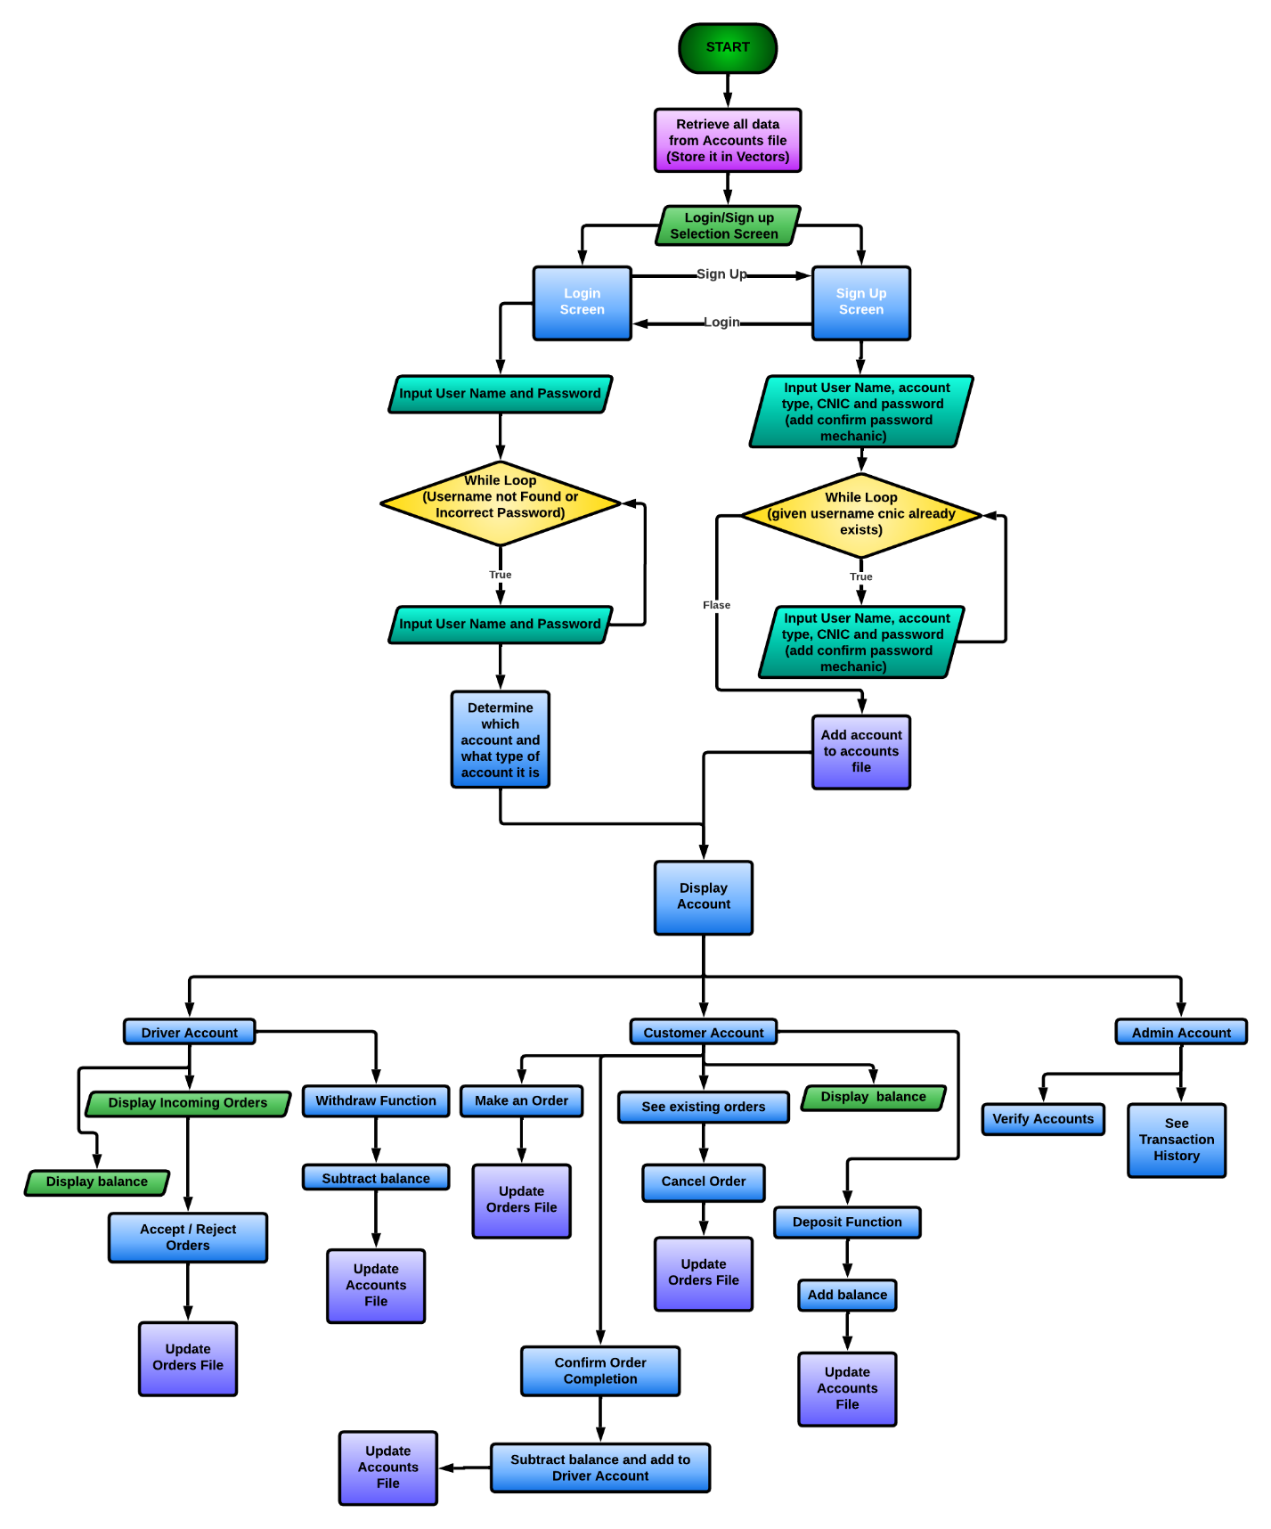~~**Rafay if youre reading this, please follow this flowchart  
(and skip account verification in admin)